FLAVOR SHOP WEBSITE

DOCUMENTATION

**Batch: C2111L**

**Authors: Tran Duy Anh**

**Nguyen Trong Duc**

**Luong Tri Khoa**

**Chu Viet Kien**

**Date: 14/09/2022**

**Instructors: Ngo Vinh Toan**

Hanoi, 14 September 2022

**Index**

Acknowledgment 4

1. Problem Definition 5

1.1. Problem Abstraction 5

1.2. Project Requirements 6

1.3. Hardware And Software Requirements 7

2. User Interface 8

2.1. Sign Up 8

2.2. Sign In 9

2.3. My profile 10

2.4. Home page 12

2.5. Product page 12

2.6. Product detail page 13

2.7. Gallery page 13

2.8. About us page 14

2.9. Contact us page 14

2.10. Wishlist page 15

3. Admin interface 16

3.1. Sign In 16

3.2. Home page 16

3.3. List product page 16

3.4. Add product 18

3.5. Add category 18

3.6. Add packing 19

3.7. Orders management 19

3.8. Contact message list 20

3.9. User management 21

4. Responsive Designs 22

4.1. iPhone 12 Pro (width – height: 390px – 844px) 22

4.2. iPad Air (width – height: 820px – 1180px) 25

4.3. Desktop 28

5. System Designs 32

5.1. Entity Relationship Diagram 32

5.2. Database Design 33

5.3. Sitemap 37

5.4. System functions design 39

6. Validation Checklists 42

6.1. Sign Up 42

6.2. Sign In 43

6.3. My profile before and after sold 44

6.4. Admin Site 45

6.5. Contact Us 49

Acknowledgment

A complete Project wouldn’t be done without any assistance. Therefore, the authors who conducted this research gratefully give acknowledge their support and motivation during the time of doing this research as a requirement for completing our eProject 1.

First, we would like to express my endless thanks and gratitude to our instructor, Mr. **Ngo Vinh Toan**. His kind support and continuous pieces of advice went through the process of completion of our eProject. His encouragement and comments had significantly, the eProject would have been impossible to be done effectively.

Second, we would like to thank Aptech learning’ teachers and staff for supporting many situations throughout the learning process and for completing this eProject.

My special thanks approve to our parents for their endless love, care, assistance, and motivation for me for the whole of my life. We also would like to explain our thanks to my siblings, brothers, and sisters for their support and care all the time.

Finally, my deep thanks come to all my friends while we study at Aptech. Their kind help, and care, will be the motivation to help us conquer the challenges later.

# Problem Definition

## Problem Abstraction

We are a young company, FLAVORS, born of a modern and affordable kitchen. We carry in our DNA the creativity, joy, and entrepreneurial spirit. More than a seasoning brand, FLAVORS is the main ingredient in an incredible story to share: a passion for food.

Good cooking for us is creative cuisine. We built our product mix uniquely uniting aromas and flavors with all the knowledge. Creativity is in the right choices: working with non-industrialized ingredients, choosing long-time producers, and caring for a healthier life. We also combine unique flavors and blends to goals that go beyond a recipe, we want to break prejudices and translate the best traditions of the good table in a current and uncomplicated way.

FLAVORS rethink how people and businesses relate to each other and thicken a new gastronomic moment. We believe in a direct and attentive relationship with each client. We architect our products to value the best moments around the table. We are encouraging the culture of eating well and good cuisine. This is the motto that makes us wake up early every day.

The company is involved in trading and manufacturing a wide range of Organic Products and spices for consumers all around the global market. The company has a wide variety of collections of products.

## Project Requirements

The portal will be designed as a Single-Page-Application and responsive Website with pages and menus representing the choice of activities to be performed. The pages, menus, and other visual elements must be designed visually appealing with attractive fonts, colors, and animations. The Web site is to be created based on the following requirements.

1. The Top of the Page should be presented with a suitable logo and banner with images of spices. The menu options should change color (fade-in and fade-out) on hover and also after clicking.
2. Sections like Best Sellers, New Arrivals, Hot Deals, and Categories should be created with a listing of products in these categories.
3. When users click on a product should open a pop-up window with details and images of the spice along with the price. Multiple images should be provided with a scrolling option.
4. A gallery should be added for viewing different images.
5. The user must be allowed to provide a review.
6. A site map, Gallery, About Us, and Contact Us links must be added.
7. About Us and Contact Us: This menu option should display the Email id, address, and contact number.
8. Navigation must be made smoother.
9. Uniformity in the design must be maintained on the website.
10. Display a continuous scrolling ticker at the bottom of the page with the current date, time, and location (hint: Use geolocation features of HTML5).
11. Display a visitor count at the top right corner of the page beside a logo image.

## Hardware And Software Requirements

# User Interface

## Sign Up

* Display registration interface.
* There are 7 pieces of information, that the user needs to enter.
* Perform data validation in cells:

1. The username and password need to have more than 3 characters.
2. Firstname, Lastname only enter type text and have more than 2 characters.
3. The email and phone number need to be in the correct format.
4. Click the “Register” button to register. If the above requirements are wrong or information doesn’t unique, an error message will be displayed. The website page will automatically switch to the verification code section if it's correct.

* After, users get the verification code in their email. Enter it, and click the “Send” button. If the verification code is correct, the account is successfully registered. If it’s incorrect, an error message will be displayed.

## Sign In

* Display the login interface.
* Users will enter the information including username and password.
* Next, click on the “Login” button and the system check:

1. Have you filled in all the information?
2. Is your login information correct? ( the same as the information registered by the user)

* If one of the above two factors is wrong, the system will report an error. If the opposite is true, login will be allowed.

## **My profile**

* The website page displays my profile interface.
* The website page displays user account information, which is registered by the user.
* Click the “My order” button to view your order and purchase history. Each order includes the order code, total money, status, and order tail. With status, is “delivering” if the user hasn’t received the goods, is “received” if the user received the goods successfully and clicked to “I have received the merchandise” button.
* 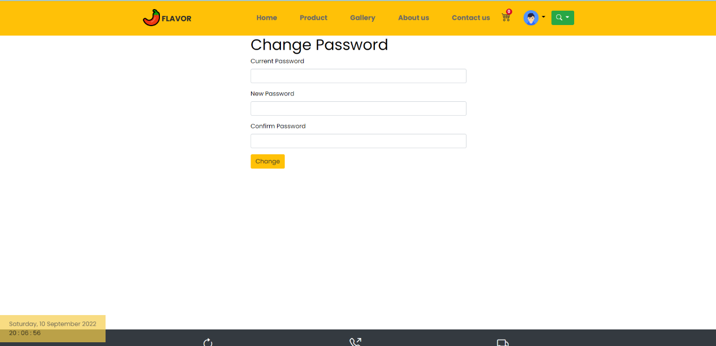Click the “Change password” button to switch to the change password section. Enter your registered password; next, enter your new password with more than 5 characters. The user fills in the information below [not empty](https://tr-ex.me/translation/english-vietnamese/not+be+empty).
* Click the “Change” button to change your password.
* 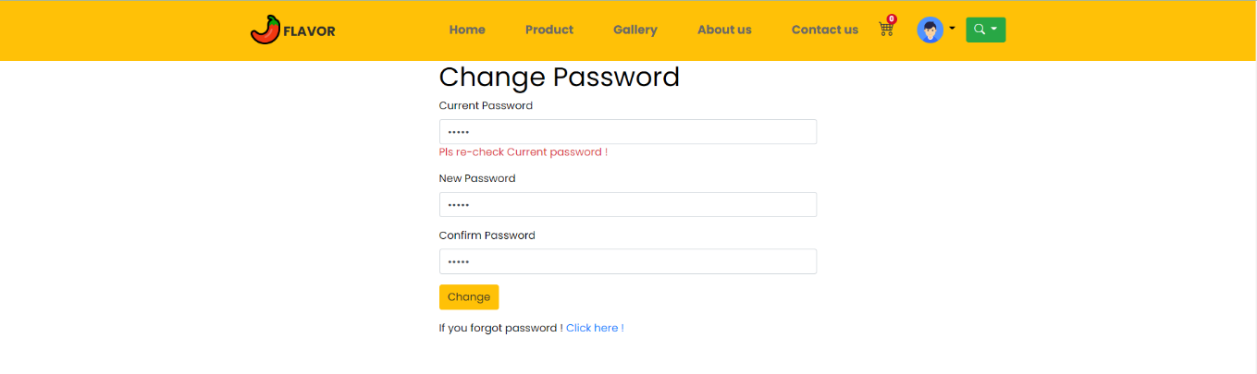If the user forgets your password, please click to text “Click here !”. The website page will automatically switch to the forgot password page.
* 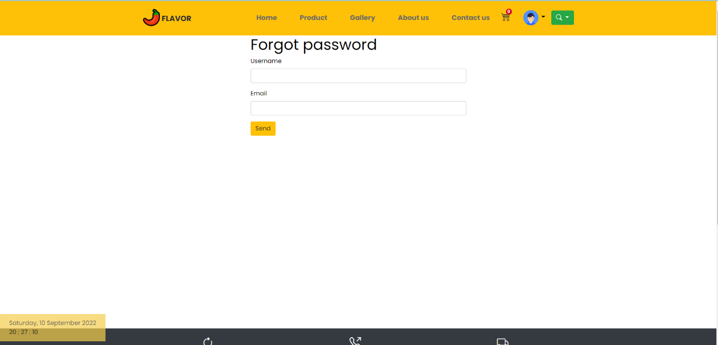The user fills in your username and email. The system will check after users click the “Send” button.

## Home page

## Product page

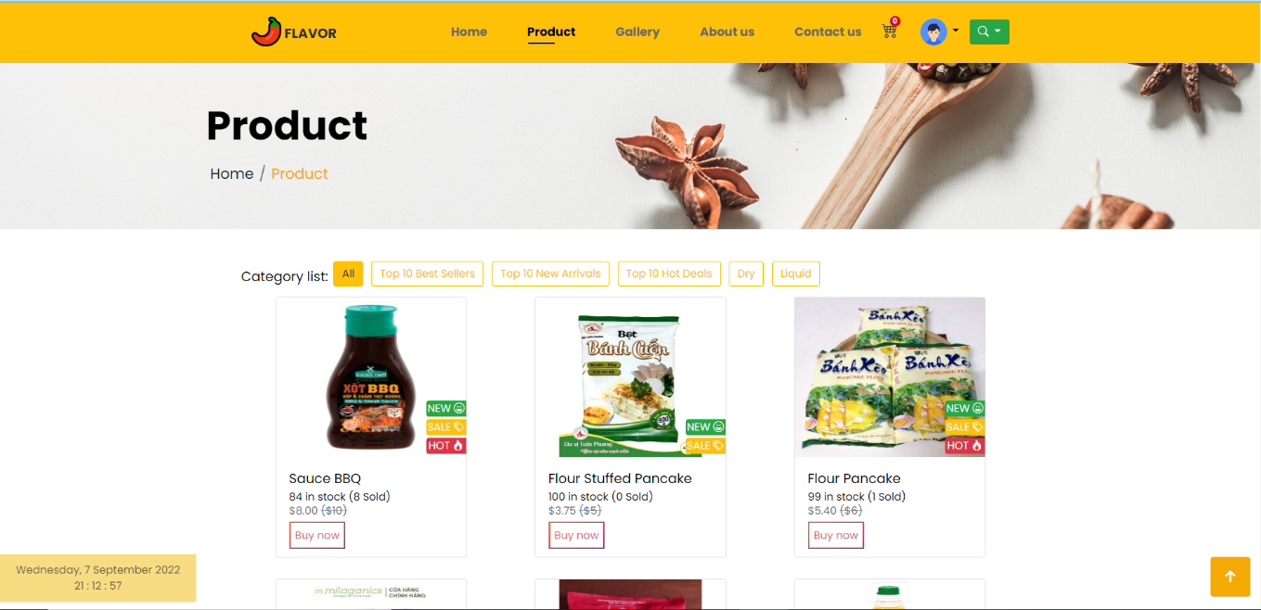

## Product detail page

## Gallery page

## About us page

## Contact us page

## Wishlist page

# Admin interface

## Sign In

## Home page

* Click on the “Log out” button to exit the login status.

## List product page

* 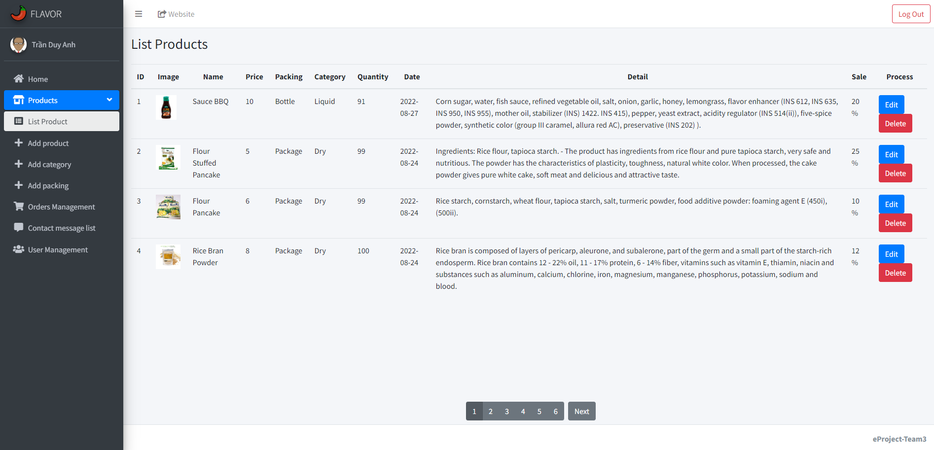Display a list of products, which are sold on a product page.
* Each product includes the id, the image of the product, name, price, packing, category, quantity, date, detail, number of sales, and process.
* With the process, the admin choices choice to do Edit or Delete the product.
* 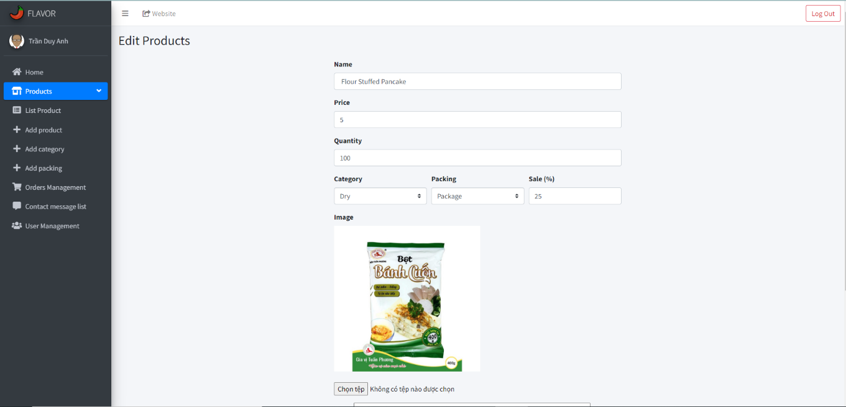When the admin clicks on the “Edit” button, the system is next to the Edit Products page. Here, the admin can change the information about the product.
* 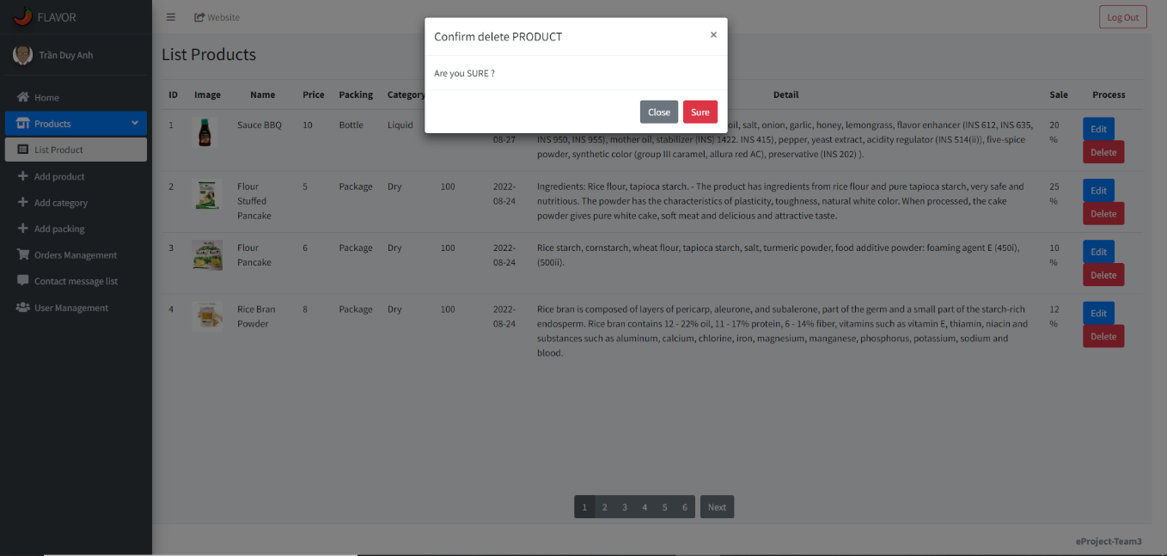If the admin choices the “Delete” button, the system asks the admin to confirm once again.

## Add product

## Add category

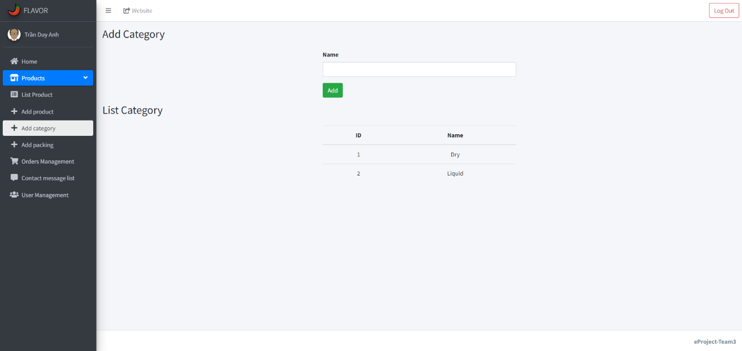

## Add packing

## Orders management

* 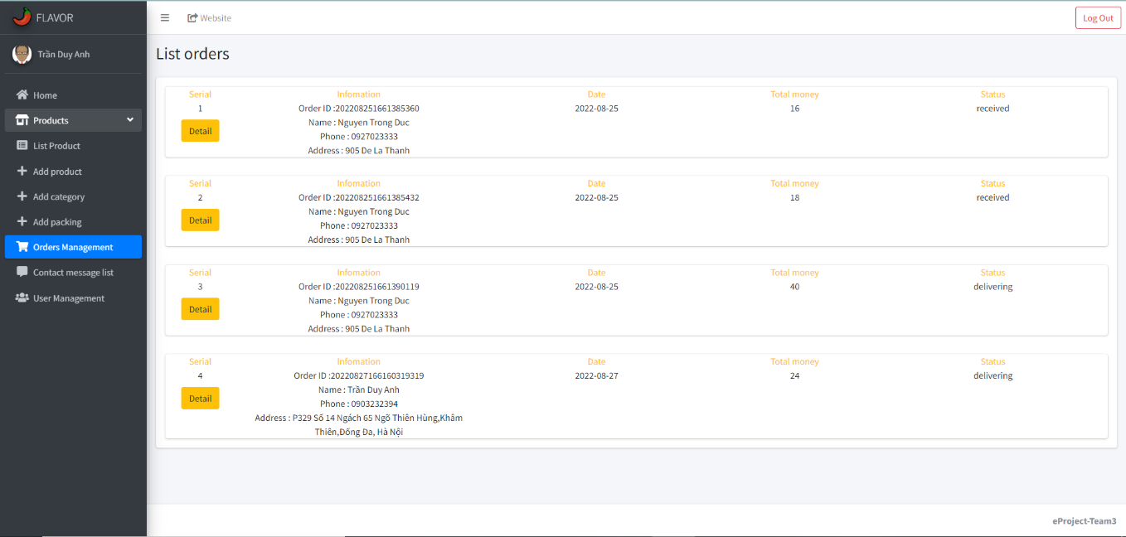Display a list of orders of various users.
* Each order includes information on the user, order date, total money, and status.
* 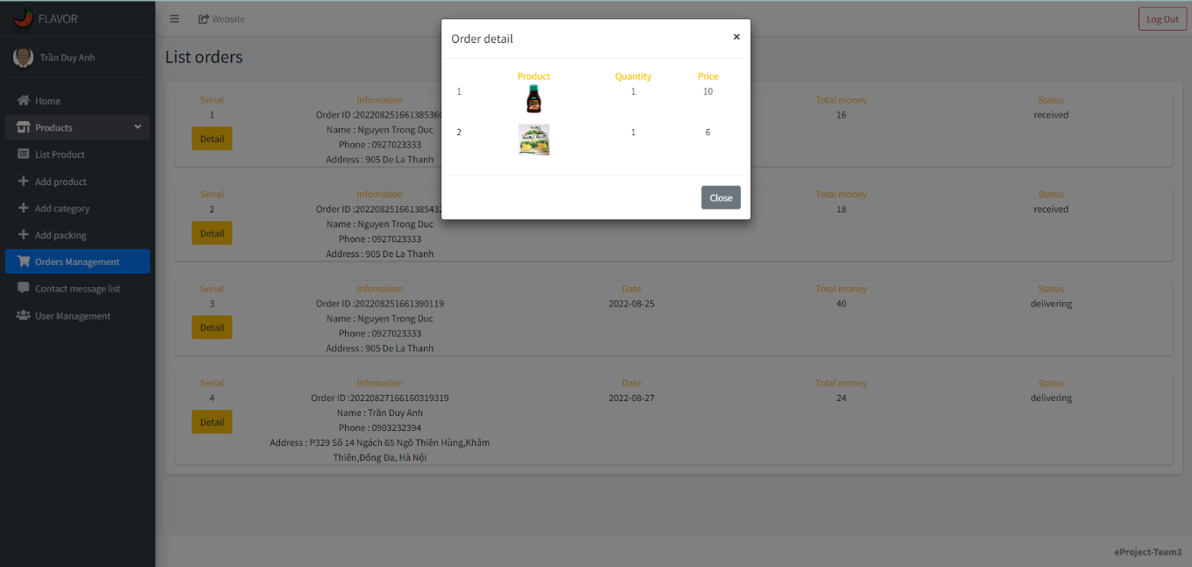With the “Detail” button, the admin can view the shopping list.

## Contact message list

## User management

* Display a list of customers who have an account with you.
* With verify section, a customer account is active if its symbol, ⌧ symbol is inactivated.

# Responsive Designs

## iPhone 12 Pro (width – height: 390px – 844px)

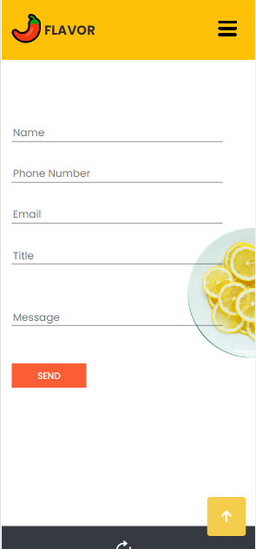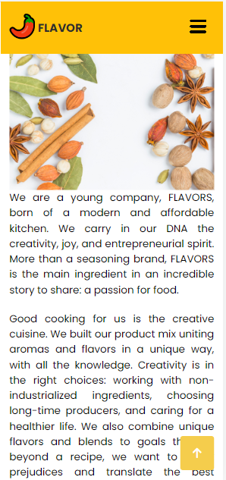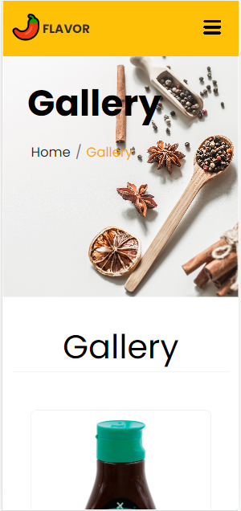

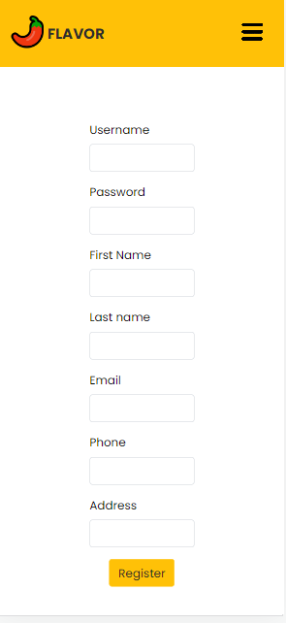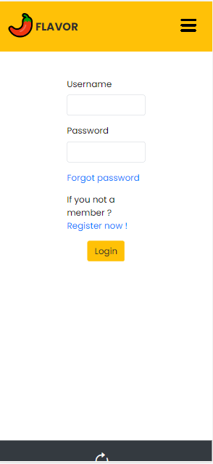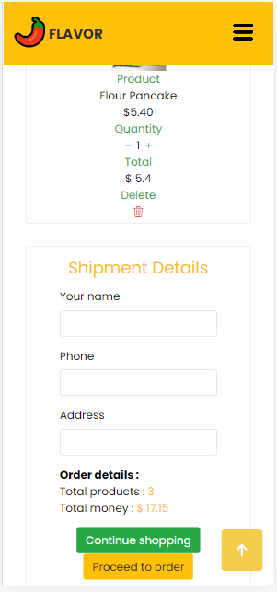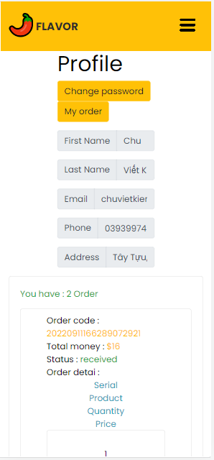

## iPad Air (width – height: 820px – 1180px)

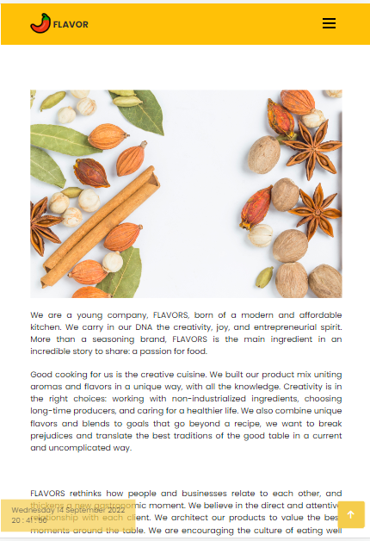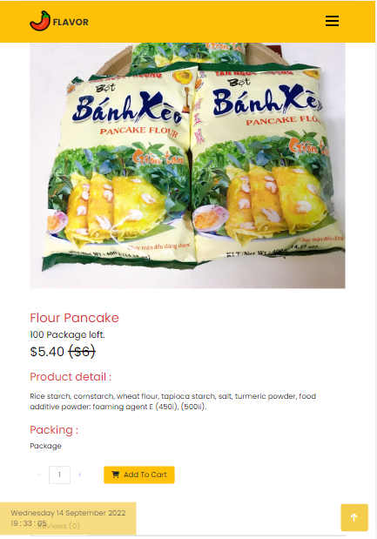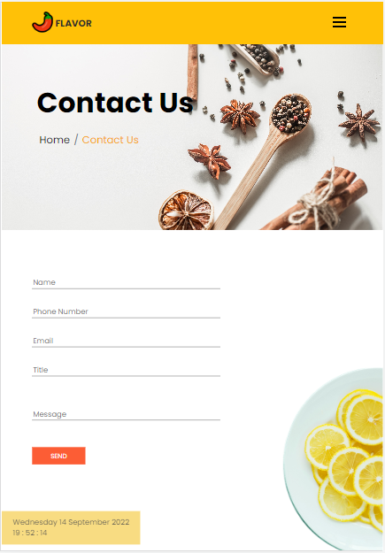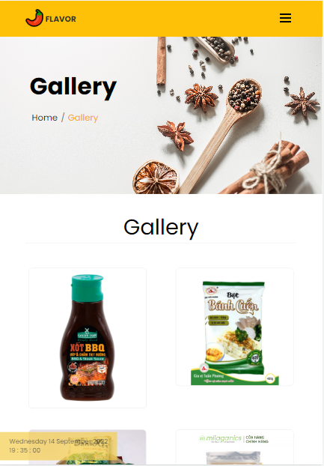

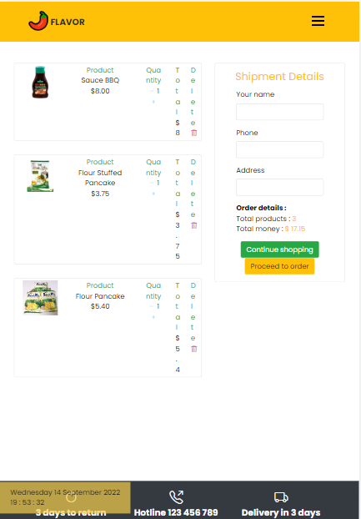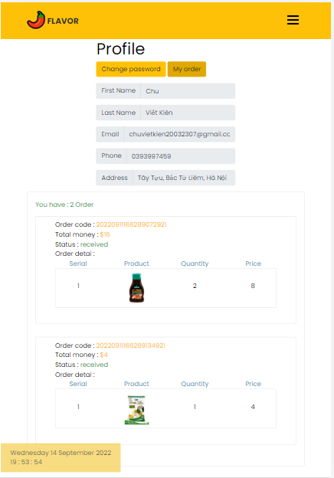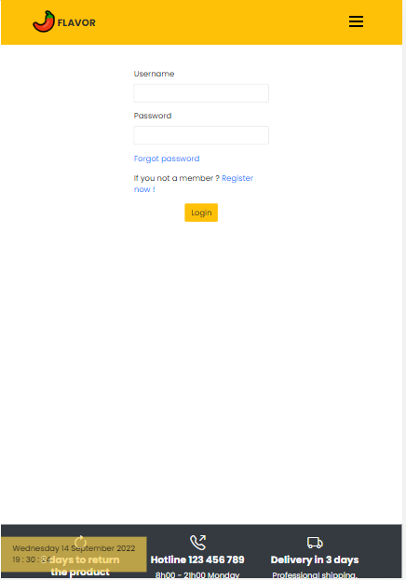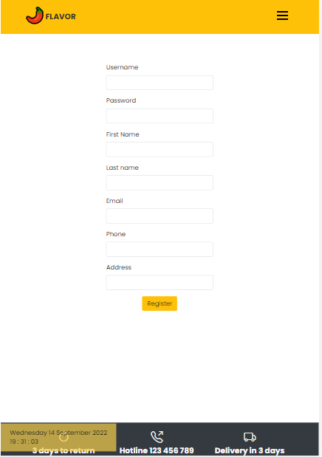

## Desktop

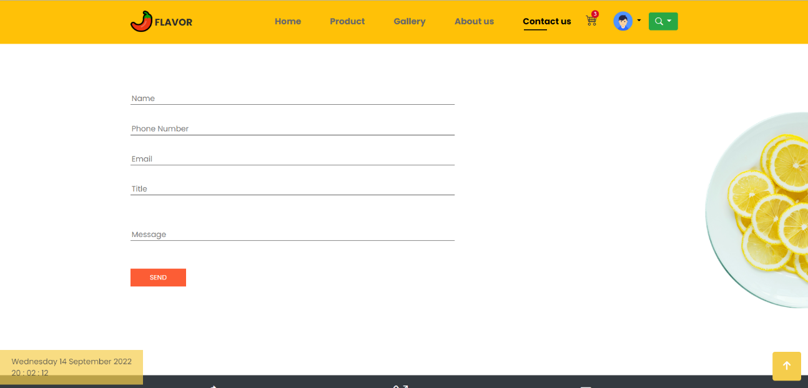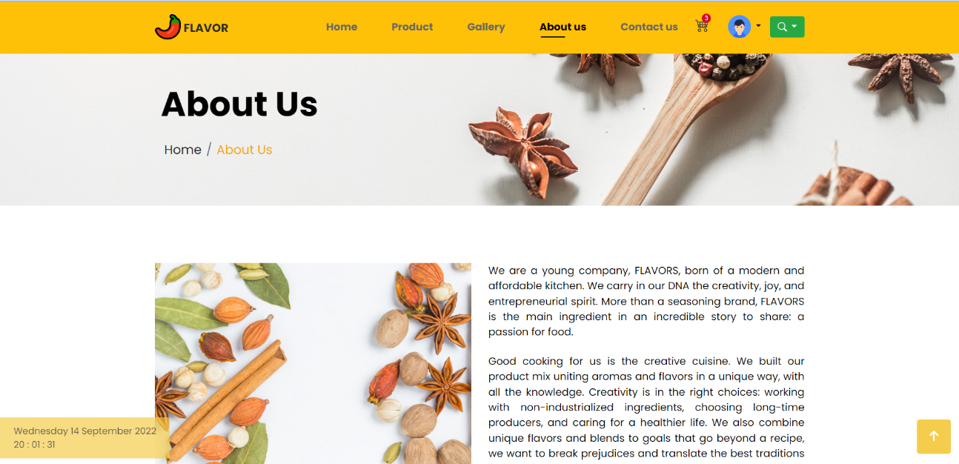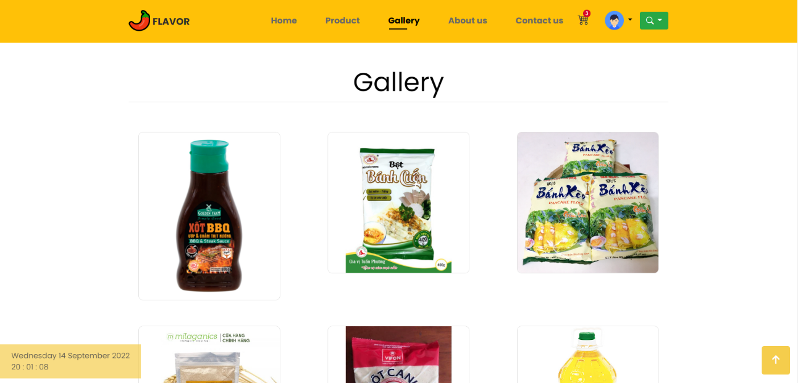

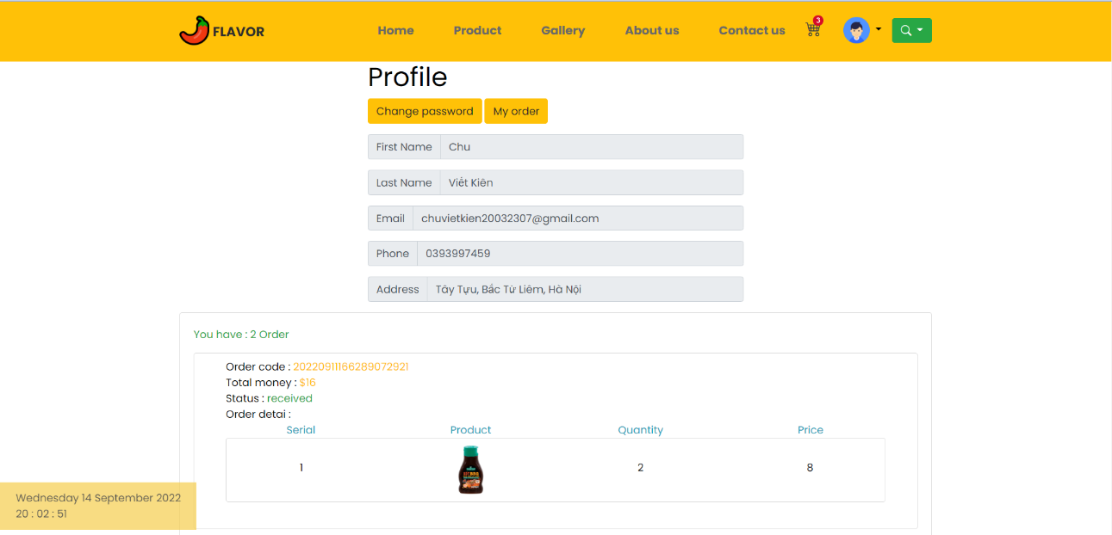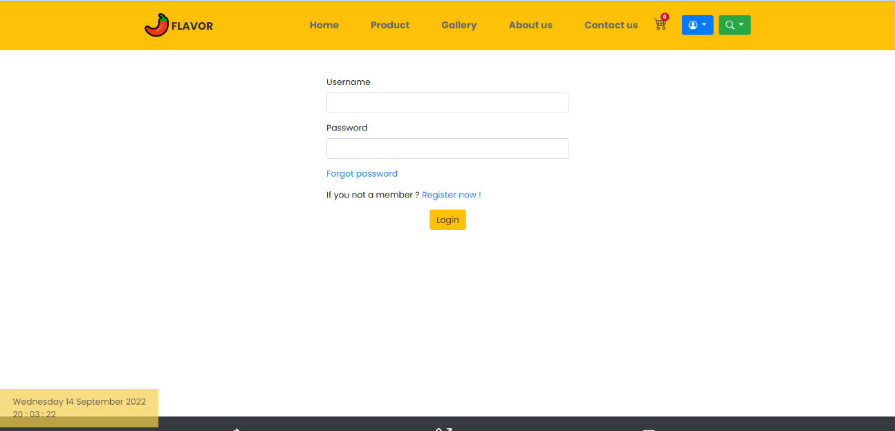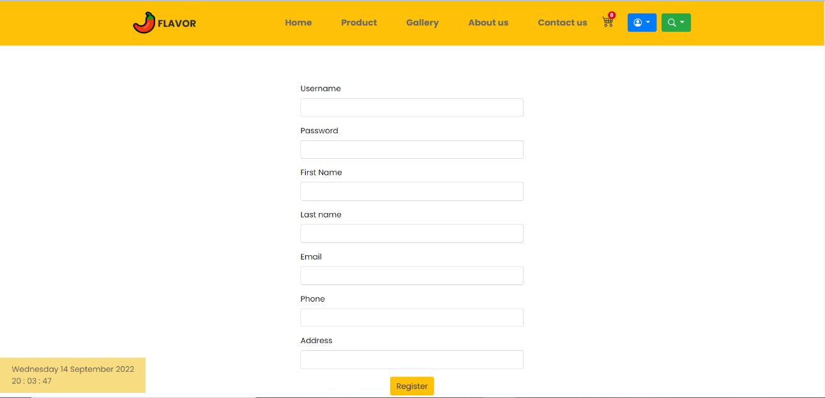

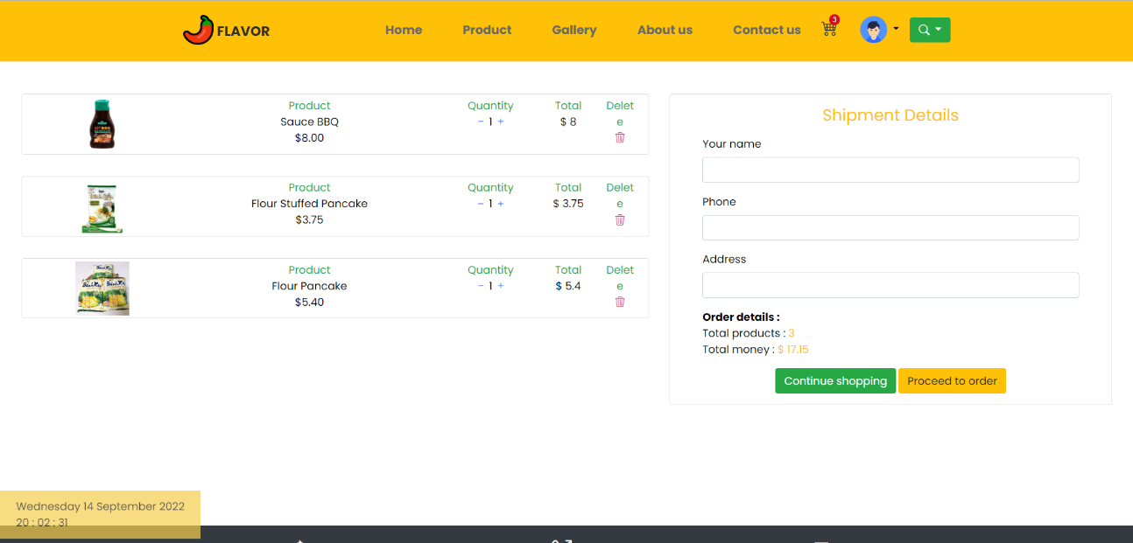

# System Designs

## Entity Relationship Diagram

Read

Create, update, delete

Admins

Products

Users

## Database Design

***DESIGNER***

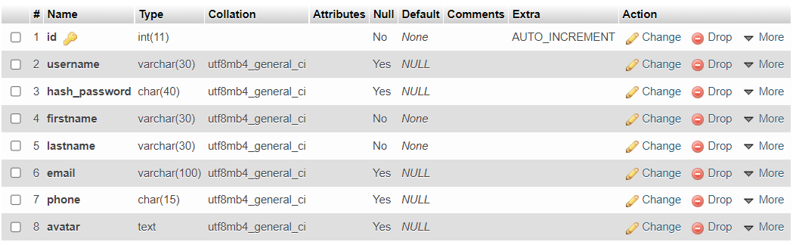

***ADMIN USER***

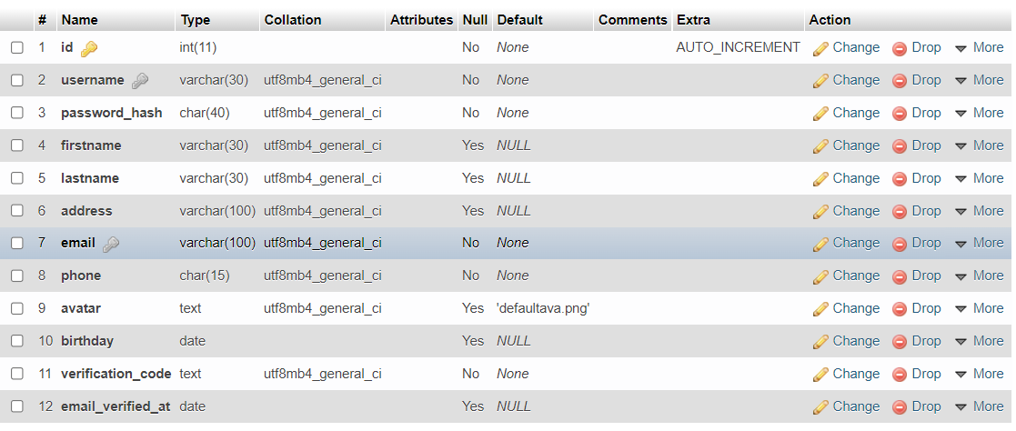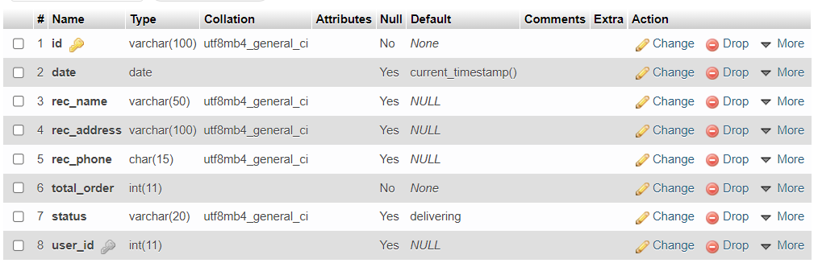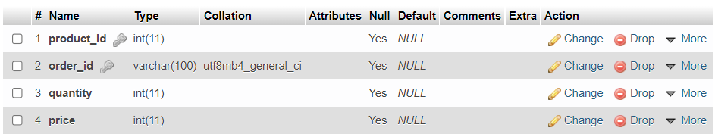***USERS***

***ORDER DETAIL***

***ORDERS***

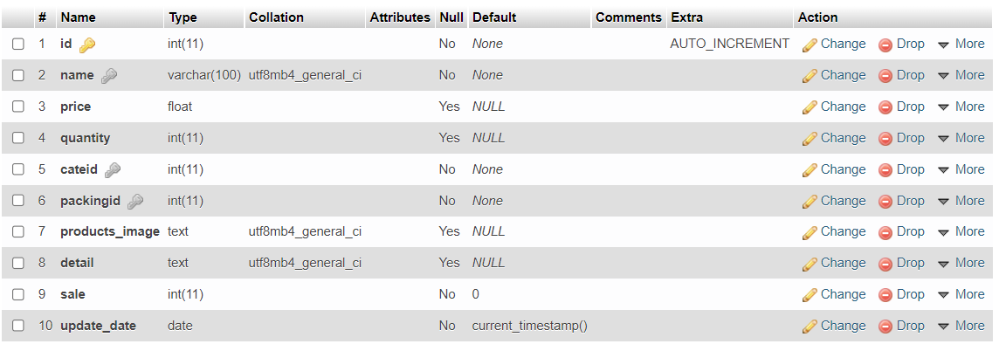***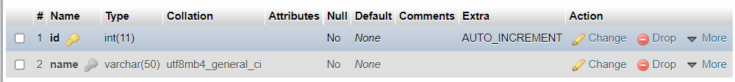CATEGORIES***

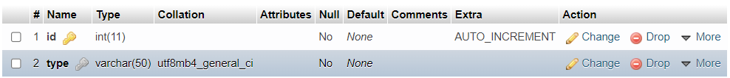***PRODUCTS***

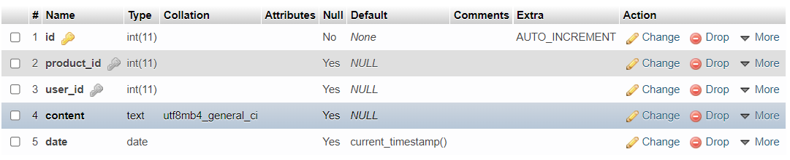***PACKING***

***REVIEWS***

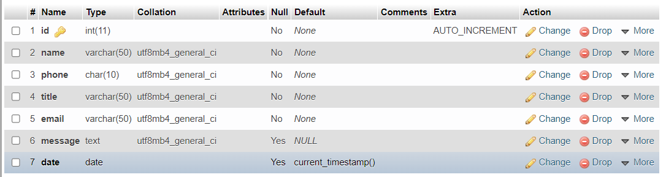***CONTACT US***

***VISITER***

## Sitemap

* + Client

Register

- Admin

About Us

Gallery

Contact Us

Cart & Ship

Products

My order

My profile

Home

Log In

Category

Delete

Update

Packing

Product

Add

User Account

Products

Orders

Contact

Log In

## System functions design

* + Registration

No

Yes

No

Yes

Register success

Create new account in database

Username, Email, Phone already exist

Empty required field

Display registration page

Input registration form

Show error message

* + Login

Display log in page

Input username and password

Empty required field

Show error message

Yes

No

Username existed

Yes

No

Password correct

Yes

No

Log in success

* + Checkout

Display order page

No

Order success

Yes

Empty required field

Submit

Yes

Yes

No

No

Show error message

Validation

Input shipment details

Log in

Logged in

# Validation Checklists

## ***Sign Up***

## Sign In

* + Data access:
  + Username: admin123
  + 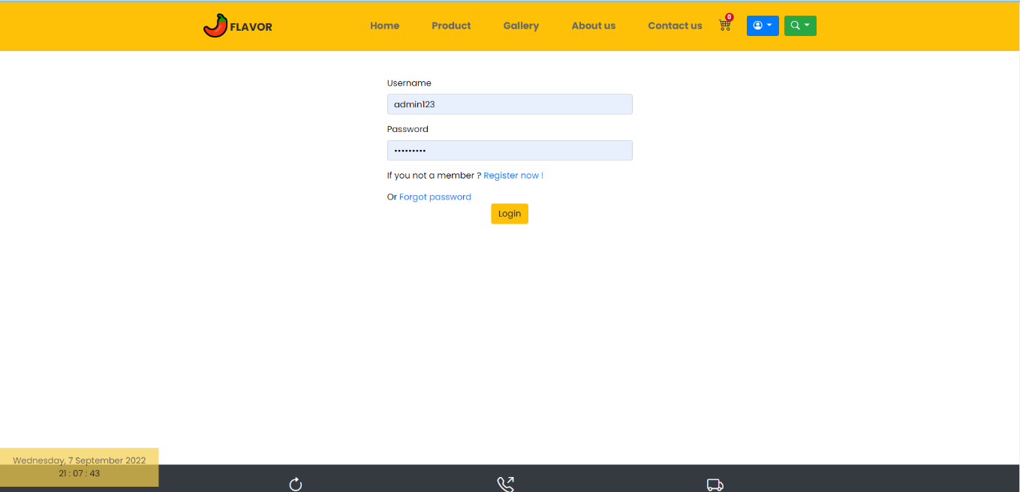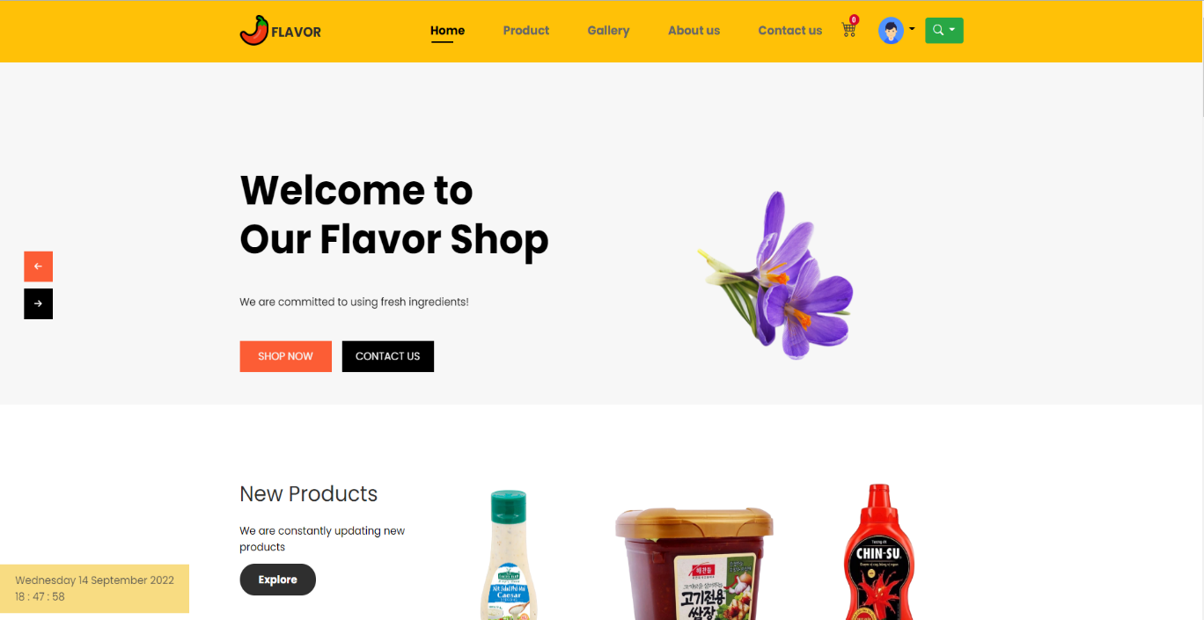Password: 123456789

## My profile before and after sold

## Admin Site

* + Data access:
  + Username: admin
  + 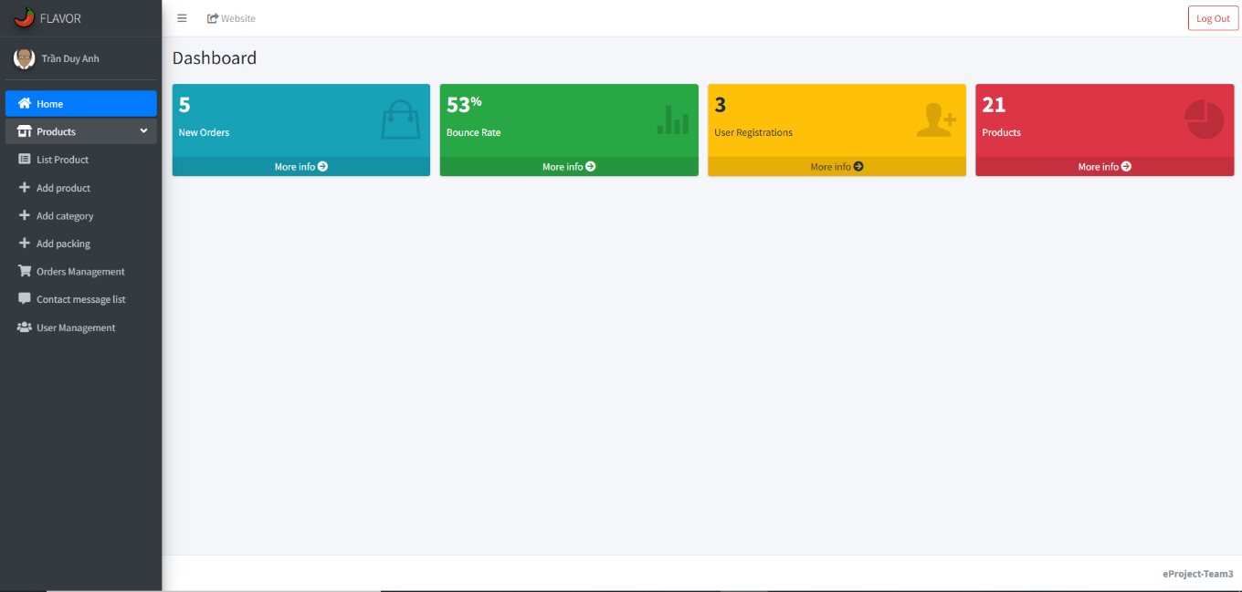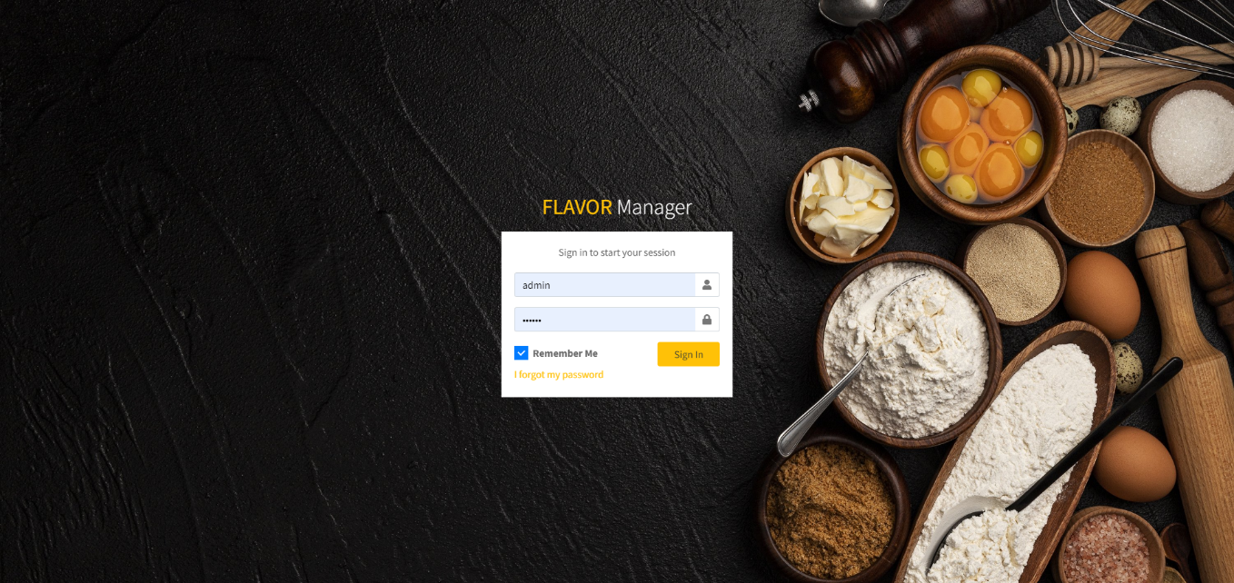Password: 123456
  + 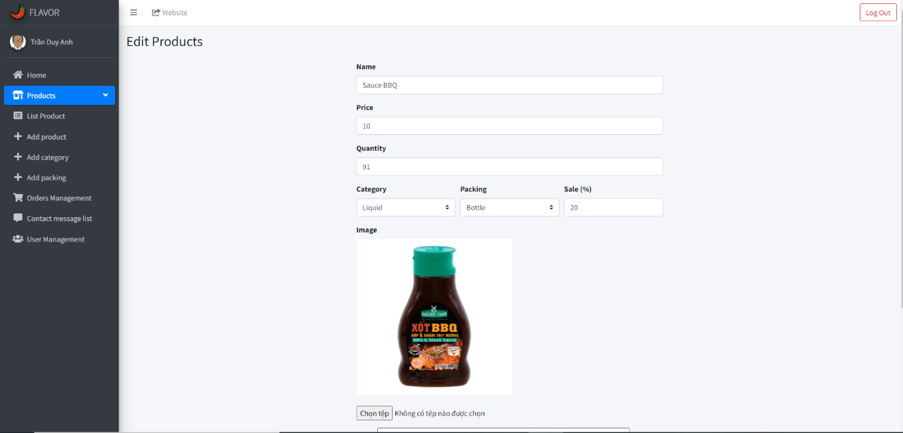Edit information on products and update them:
  + 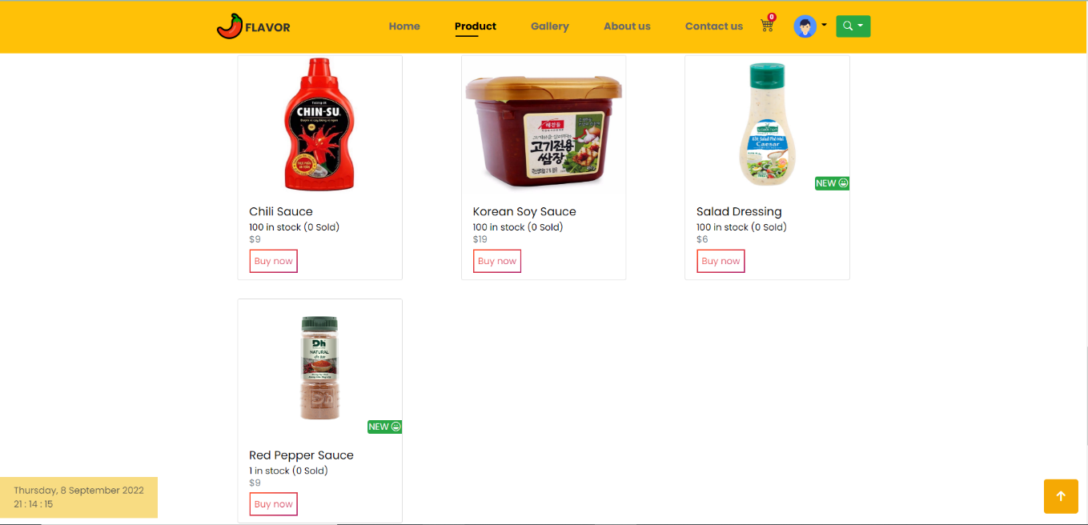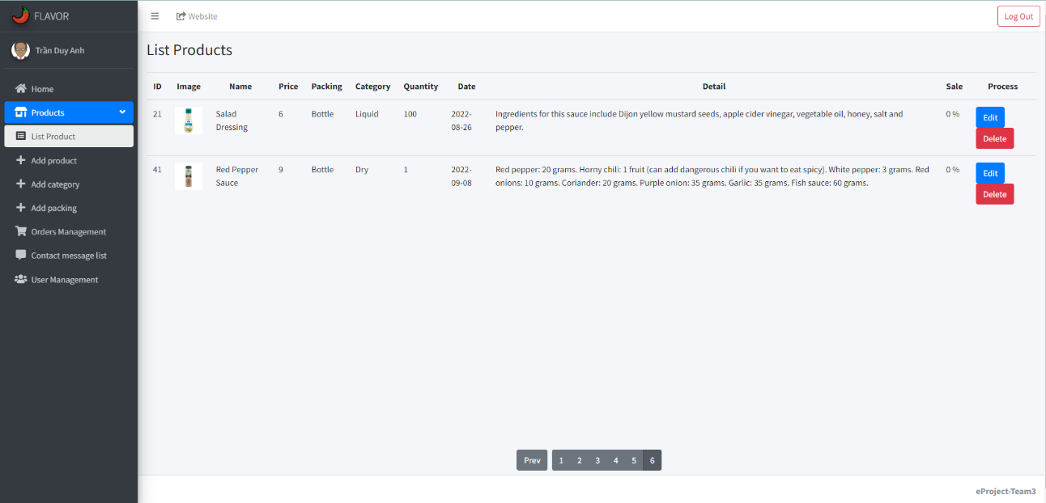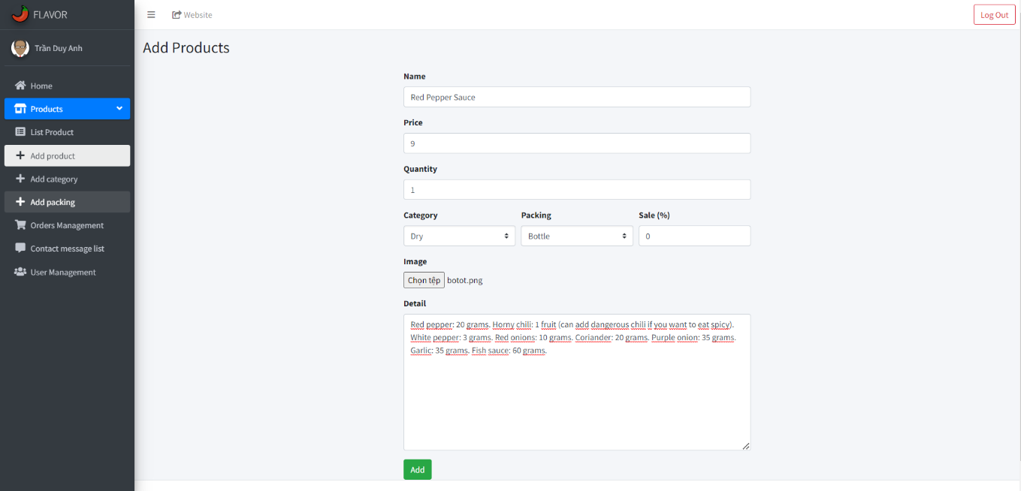Add products to the list sold:
  + Add a category of products and packing:

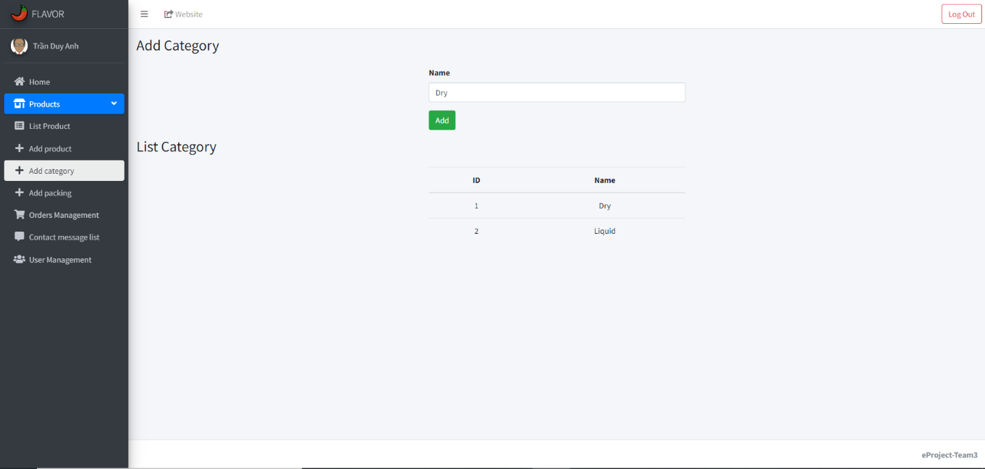

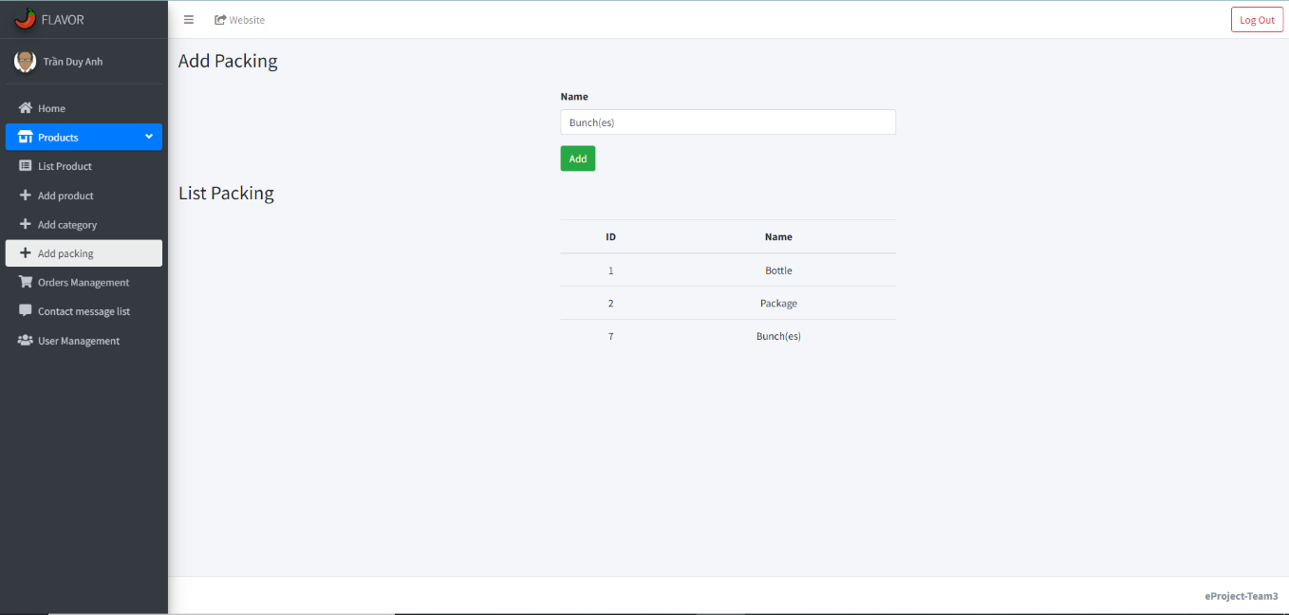

## Contact Us